1. Website Specifications
a. Objective & Goals
OwenScents is an online store for browsing and buying fragrances. The goals are to showcase products clearly, make navigation simple, encourage online sales, and build a strong brand identity.
b. Target Audience
The site targets adults aged 18–40 interested in fashion and online shopping, for both men and women. They have basic web skills like browsing and filling out forms.
c. Type of Website
This is an E-commerce website designed for users to view products, explore details, and make purchases.
2. Information Design & Taxonomy
Main Pages (Site Map):
- Home
- Shop
- Cart
- About Us
- My Account
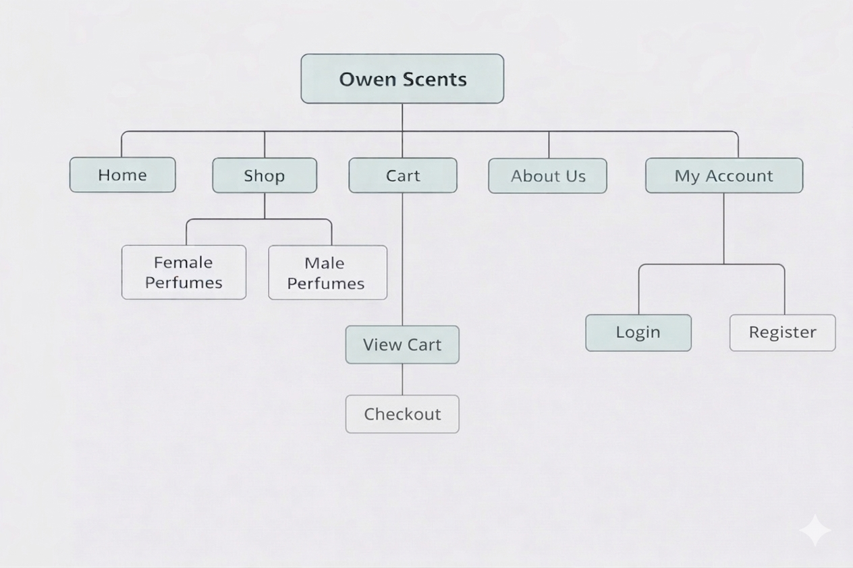
Navigation Flow:
Users land on the Home page, where they can view featured products.
They use the navigation bar to go to the Shop page, which displays all available fragrances.
From the Shop page, users can select perfumes either from the female perfumes section or the male perfumes section and add them to their Cart.
The Cart page allows users to review selected items and proceed with checkout. At the About Us page users can learn more about Owen Scents company. From the My Account page users can create their accounts for the Owenn Scents online Store so that their Information can be saved and not lose progress of adding perfumes to the cart.
Content Organization:
Perfumes are displayed in cards, with a top navigation bar and clearly separated sections for reviews and key content.
3. Page Template Design
The layout is consistent across all pages:
- Header: Logo and navigation menu.
- Main Content: Slideshow, product cards, store description, customer reviews.
- Footer: Contact, Email, Follow Us, Copyright info.
Design Features:
Built with Bootstrap for responsiveness. Uses cards for products, a carousel for featured images, and a clean black/white/neutral colour scheme for a professional, readable look.
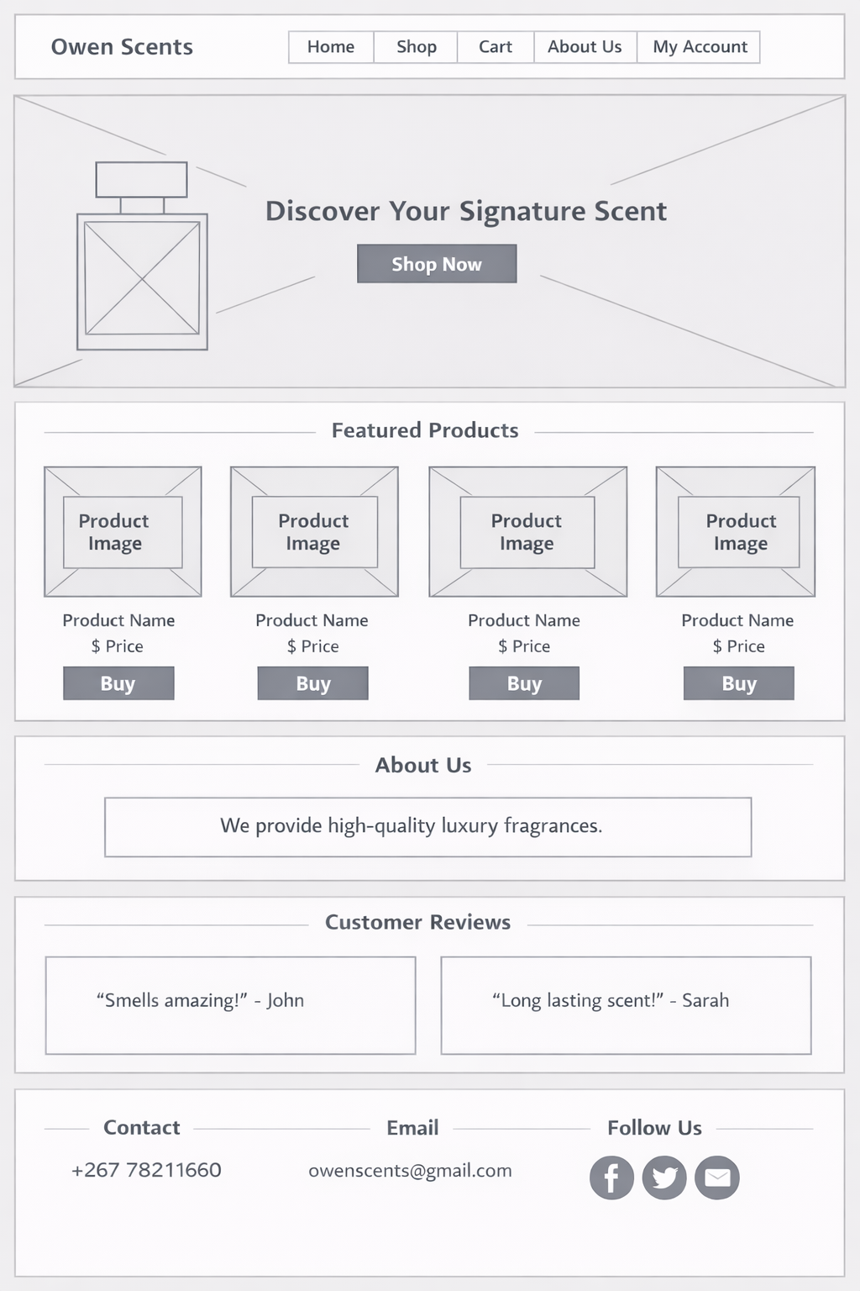
4. Technical Brief
Technologies Used:
- HTML: Page structure.
- CSS: Styling and layout.
- Bootstrap: Responsive design and components.
Tools:
VS Code (editor), web browsers (testing), image assets.
Why:
HTML/CSS are essential, Bootstrap speeds up responsive development, and the tools match the project's scope.
5. Quality Assurance
Tests Conducted:
- Browser testing (Chrome, Edge)
- Mobile responsiveness
- Navigation (links/buttons)
- Layout (alignment/spacing)
Results:
The site loads correctly across browsers, navigation works, and the layout adapts well to different screen sizes.
(Add screenshots of your site on desktop and mobile here.)
6. Publishing & Promotion
Method: Host on GitHub Pages.
Steps:
- Create a GitHub repository.
- Upload HTML, CSS, and image files.
- Enable GitHub Pages in settings.
- Share the generated link.
Tools: GitHub, basic Git commands.
7. Future Developments
Potential improvements include:
- User login/accounts
- Online payment integration
- Search and filter options
- Animations and transitions

